Kellie Linehan
CSC 493: CS Capstone Project
February 12, 2026
Dr. Nathalie Japkowicz
Capstone Project Proposal
Introduction, Goals, & Vision
In today’s landscape, analytics are becoming increasingly useful and relevant for gaining a competitive advantage in college athletics. This includes many college basketball programs collecting lots of detailed data; however, a lot of that information never turns into clear, practical insight for coaches and players. At American University, the Kogod analytics project, which I have been involved with, has already started this process with manual shot tracking and basic descriptive stats, but there are still no predictive models or interactive dashboards that show which players fall short of or beat shooting expectations in specific situations. In this project, my goal is to fill that gap by building one or two focused machine learning models that estimate key shooting metrics, such as shot success probability and expected points. I will then embed these models into a dashboard that is easy for players, coaches, and staff to interact with.
My goal is to create a tool that provides affordable player-level analytics for smaller Division I programs with limited data and resources. Systems like Second Spectrum or Synergy are powerful, but geared towards large organizations, like the NBA, that have huge datasets. Other widely used college sites like KenPom and BartTorvik mostly provide team level summaries that don’t capture player and context specific shooting patterns (Pomeroy). My project builds directly on the existing Kogod data that is being cleaned and ready to use. I am taking these cleaned and validated shot logs, making predictive models and creating an interactive interface where users can filter by player, game situation, or shot type and immediately see performance relative to expectations.
By the end of the semester, I plan to deliver a working dashboard that the Kogod analytics team and AU coaching staff can actually use with predictive models that perform well. I will consult the Kogod team in our weekly meetings to make sure that the tool is intuitive and the insights feel useful for real decision-making. This scope is realistic for a semester-long project because it requires data cleaning, feature engineering, model development, evaluation, and UI design. I am purposely focusing on a small set of metrics and a single team-focused dashboard so that I can make it as useful as possible. In order to complete the whole project, I am applying ideas from previous coursework in machine learning, sports analytics, and software engineering.
Positioning
This project combines basketball analytics, machine learning, and decision support for college athletics. Shot probability models and expected-value metrics have been explored and researched, but most existing tools are either proprietary, focused on the NBA, or designed for huge datasets that smaller college programs don’t have access to. As a result, there is a gap between what is discussed in sports analytics literature and what is realistic for a smaller Division I program like American University.
Many prior studies have modeled the probability that a basketball shot goes in using logistic regression and similar methods, showing that features such as shot distance, defender distance, shot type, and game context are important predictors of success (Schliep). For example, multiple projects have built logistic regression models on NBA shot tracking data to estimate shot-making probability and then compare players’ actual performance to model expectations (Mourri, et.al). Other work has proposed “expected points” metrics, which combine shot probability with shot value to evaluate players and teams based on how many points they score compared to an expected baseline (PowerRank). These approaches provide a technical foundation for comparisons of actual versus predicted shot performance.
Most existing basketball analytics systems depend on extensive tracking data and expensive platforms like Second Spectrum and Synergy, which are not realistic for a program like AU. On the other hand, college sites such as KenPom and BartTorvik provide team level metrics rather than player level, context-aware shooting insights that a single team can plug its own data into. The current Kogod project focuses on manual shot tracking and descriptive statistics, but does not yet include predictive models or an interactive dashboard. My project will fill this gap by applying models such as logistic regression to AU’s manually collected shot logs, creating expected value metrics at a player level, and displaying them through an accessible dashboard that provides coaches with clear, actionable information.

Methodology
While creating this project, I am going to focus on four main sections: preparing the data, building models, creating analytics, and building a dashboard for users.
I will start off by taking the shot tracking data that the Kogod team has already collected and cleaning it up by fixing errors, handling missing values, and making sure all of the fields are consistent.
After this, I will start building the models. I plan to start with a simple model like logistic regression to predict the chance that a shot goes in and then use those probabilities to calculate expected points. I will split the data into training and test sets based on different games or practices so I can see how well the model works on new data. I also have the advantage of being able to continuously collect new data as more practices and games are played, so I will be able to see how the models perform on this data. Next, I will evaluate the models to see how well the predicted probabilities match real outcomes, and add extra complexity if it improves the results without overcomplicating the model.​​
After that, I will create the analytics layer by using the model outputs to calculate player and situation metrics. For example, how many points a player scores compared to what the model would expect in certain locations or game situations. I will summarize these results in short phrases so that coaches can easily see where players are over or underperforming.​
Lastly, I will build the dashboard and use either a Python based tool, such as Streamlit or Dash, or an R-compatible tool, such as Shiny, to connect the cleaned data and models to an interactive UI. The dashboard will let users filter by player, game, situation, or shot type and will show shot charts, tables, and short summaries that highlight key insights. Throughout the semester, I will get feedback from the Kogod analytics team and use it to adjust the layout, filters, and explanations so the dashboard is easy to use and actually helpful for real basketball decisions.
Testing
For model testing, I will keep some games or practices out of the training process and use them only as a test set to see how well the model works on data it has not seen before. I will check simple metrics like how often the model correctly predicts whether a shot goes in and how well the predicted probabilities match real outcomes. In addition, because new practices and games will happen during the semester, I will be able to keep adding fresh shot data and use it as a future test set to see whether model performance holds up over time, not just on the original sample. If I notice the model isn’t performing well on this newer data, I will revisit my features or modeling choices and retrain as needed.
When testing the dashboard, I will make sure all filters behave correctly and that changing them updates the charts, tables, and summaries. I will also run informal usability tests by asking members of the Kogod analytics team to perform simple tasks, and then ask whether the interface is clear, the labels make sense, and if the information is easy to interpret. Based on their feedback, I will make changes so the dashboard feels straightforward and helpful.
Organization & Timeline
Since this is an individual project, I am responsible for all parts of the work, but I am still organizing it into clear pieces.I will also set up regular check-ins with the Kogod analytics team, so they can act as stakeholders, help me shape requirements and give feedback as the project develops.
Additionally, I will create a timeline with clear deadlines for each main part of my project, including data cleaning, model building, dashboard development, testing, and writing the final report. Even though I am working alone, I still plan to work on some pieces at the same time, for example, starting dashboard design while I am refining the models, so that progress continues across all aspects of the project. I will choose realistic deadlines for each stage and update them if needed so that I can stay on top of the project and deliverables.
Overall, this project will turn AU’s manually collected shot data into a simple, usable decision-support tool by combining interpretable models with an accessible dashboard. By the end of the semester, my goal is to deliver a working prototype that coaches and staff find accurate, understandable, and helpful for real basketball decisions.

Appendix:

Timeline
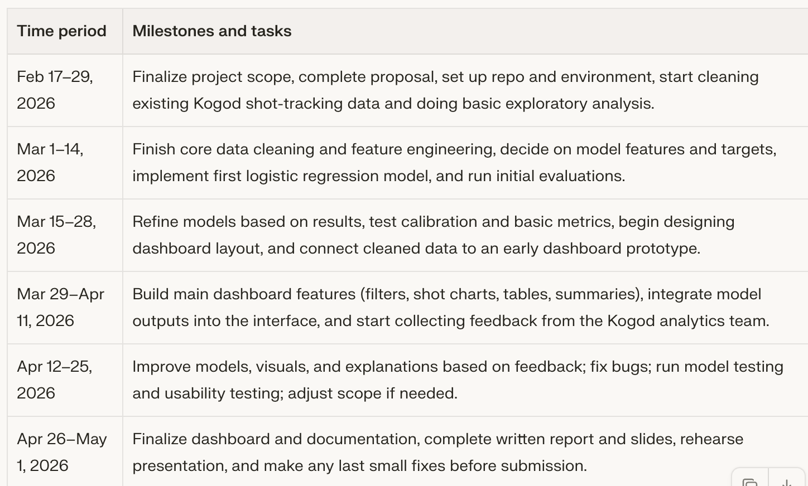
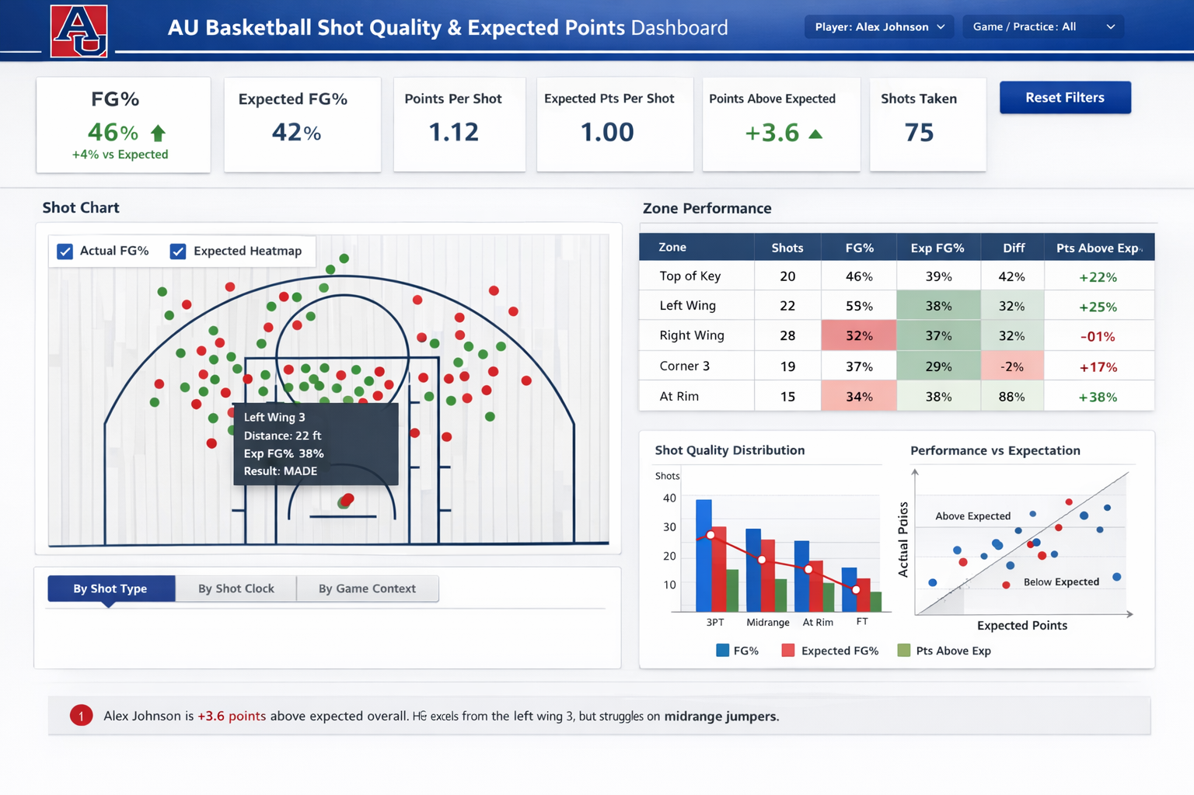
Dashboard Mockup

References
Borelli, A. (2022). Analyzing NBA shot success through expected points. Take a Number. https://takeanumber.substack.com/p/analyzing-nba-shot-success-through
Brown, B. (2019). Using logistic regression for determining the outcome of a game [Honors thesis]. University of New Hampshire. https://scholars.unh.edu/cgi/viewcontent.cgi?article=1471&context=honors
Cheema, A., Henehan, C., & Stuckart, C. Modeling shot probability in the NBA .https://www.causeweb.org/usproc/sites/default/files/usclap/2021-1/Modeling%20Shot%20Probability%20in%20the%20NBA.pdf
Mourri, Y. B., Goyal, A., & Shayer, E. NBA shot probability model [Course project]. Stanford University, CS229: Machine Learning. https://cs229.stanford.edu/proj2016spr/poster/001.pdf
Murakami-Moses, M. Analysis of machine learning models predicting basketball shot success [Conference paper]. International Young Researchers Conference. https://www.the-iyrc.org/uploads/1/2/9/7/129787256/20_iyrc2020_35_final.pdf
Pomeroy, K. (2026). Pomeroy College Basketball Ratings. Retrieved from https://kenpom.com
PowerRank, T. The ultimate guide to predictive college basketball analytics. The Power Rank. https://thepowerrank.com/cbb-analytics/
Schliep, E. (2025). A novel NBA player metric based on Bayesian hierarchical modeling. arXiv. https://arxiv.org/html/2405.10453v2
Torvik, B. (2025). T-Rank: Customizable College Basketball Tempo-Free Stats. Retrieved from https://barttorvik.com
**Used perplexity AI for outlining the structure of the report, finding Pomeroy and Torvik sources, and creating the timeline graphic in the appendix
** Used ChatGPT to create the dashboard mockup visual

